**Docker Images and Containers**

Completion requirements

**Done: View**

**3. Environment Preparation**

**What You'll Do**

* You will prepare your computer for using Docker in the following exercises.

**Instructions**

**Docker Desktop and VS Code Docker extension**

**Docker Desktop**

* You should have installed Docker Desktop in the previous course. If you did not, or you are using a different computer, return to [the previous course's instructions to install Docker Desktop](https://learn.nucamp.co/mod/page/view.php?id=5460).
* Make sure that **Docker Desktop** is running before you continue.

**VS Code Docker extension**

* In VS Code, open the Extensions panel by clicking on this icon on the left: 
* Confirm that the **Docker** extension appears in the list of installed extensions.
* If you do not see it in that list, you must install it.
* Type **docker** into the search bar, then click on the extension:  
  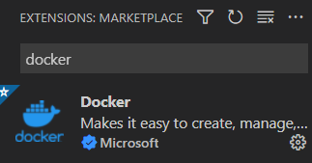
* Finally, click the Install button on the extensions page. It will be in the same location as where the Uninstall button appears below:  
  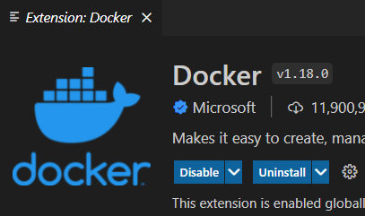

**Stop running containers**

* In the SQL course, you used Docker to run PostgreSQL and pgAdmin containers.
* In order to prevent these containers from interfering with your Docker exercises in this course, we will stop them now if they are running.
* You can stop these from the Docker Desktop application, or via the command line.

**Stop containers using Docker Desktop**

* To stop the containers from Docker Desktop, open it and view running containers in the Containers/Apps panel.
* If the containers from the SQL course are running, you will see this:  
  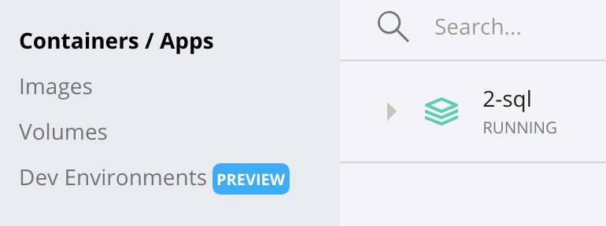
* It may also look like this, which means the containers have been stopped but not removed:  
  
* Hover over the **2-sql**app, and you will see a trash can icon appear to the right. Use it to delete the containers.

**Stop containers using the command line**

* Alternatively, you can stop the containers using the command line.
* From a bash terminal open to any folder, use the following commands:

docker stop pg_container

docker stop pgadmin_container

docker rm pg_container

docker rm pgadmin_container